**Cloud Computing: UE20CS352**

**Experiment 3**

**-Adithya M, Section K**

**-PES1UG20CS621**

**● Screenshot 1a: Creation of table (1 mark)**

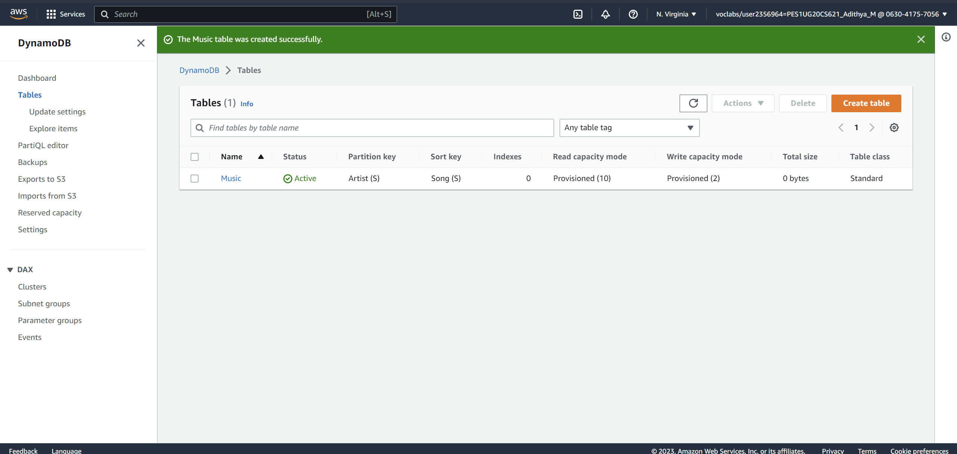

**● Screenshot 2a: Show the inserted entries in table (Make sure the Items returned table is expanded such that all fields are shown and the name of the Table is also visible to the left) (2 marks)**

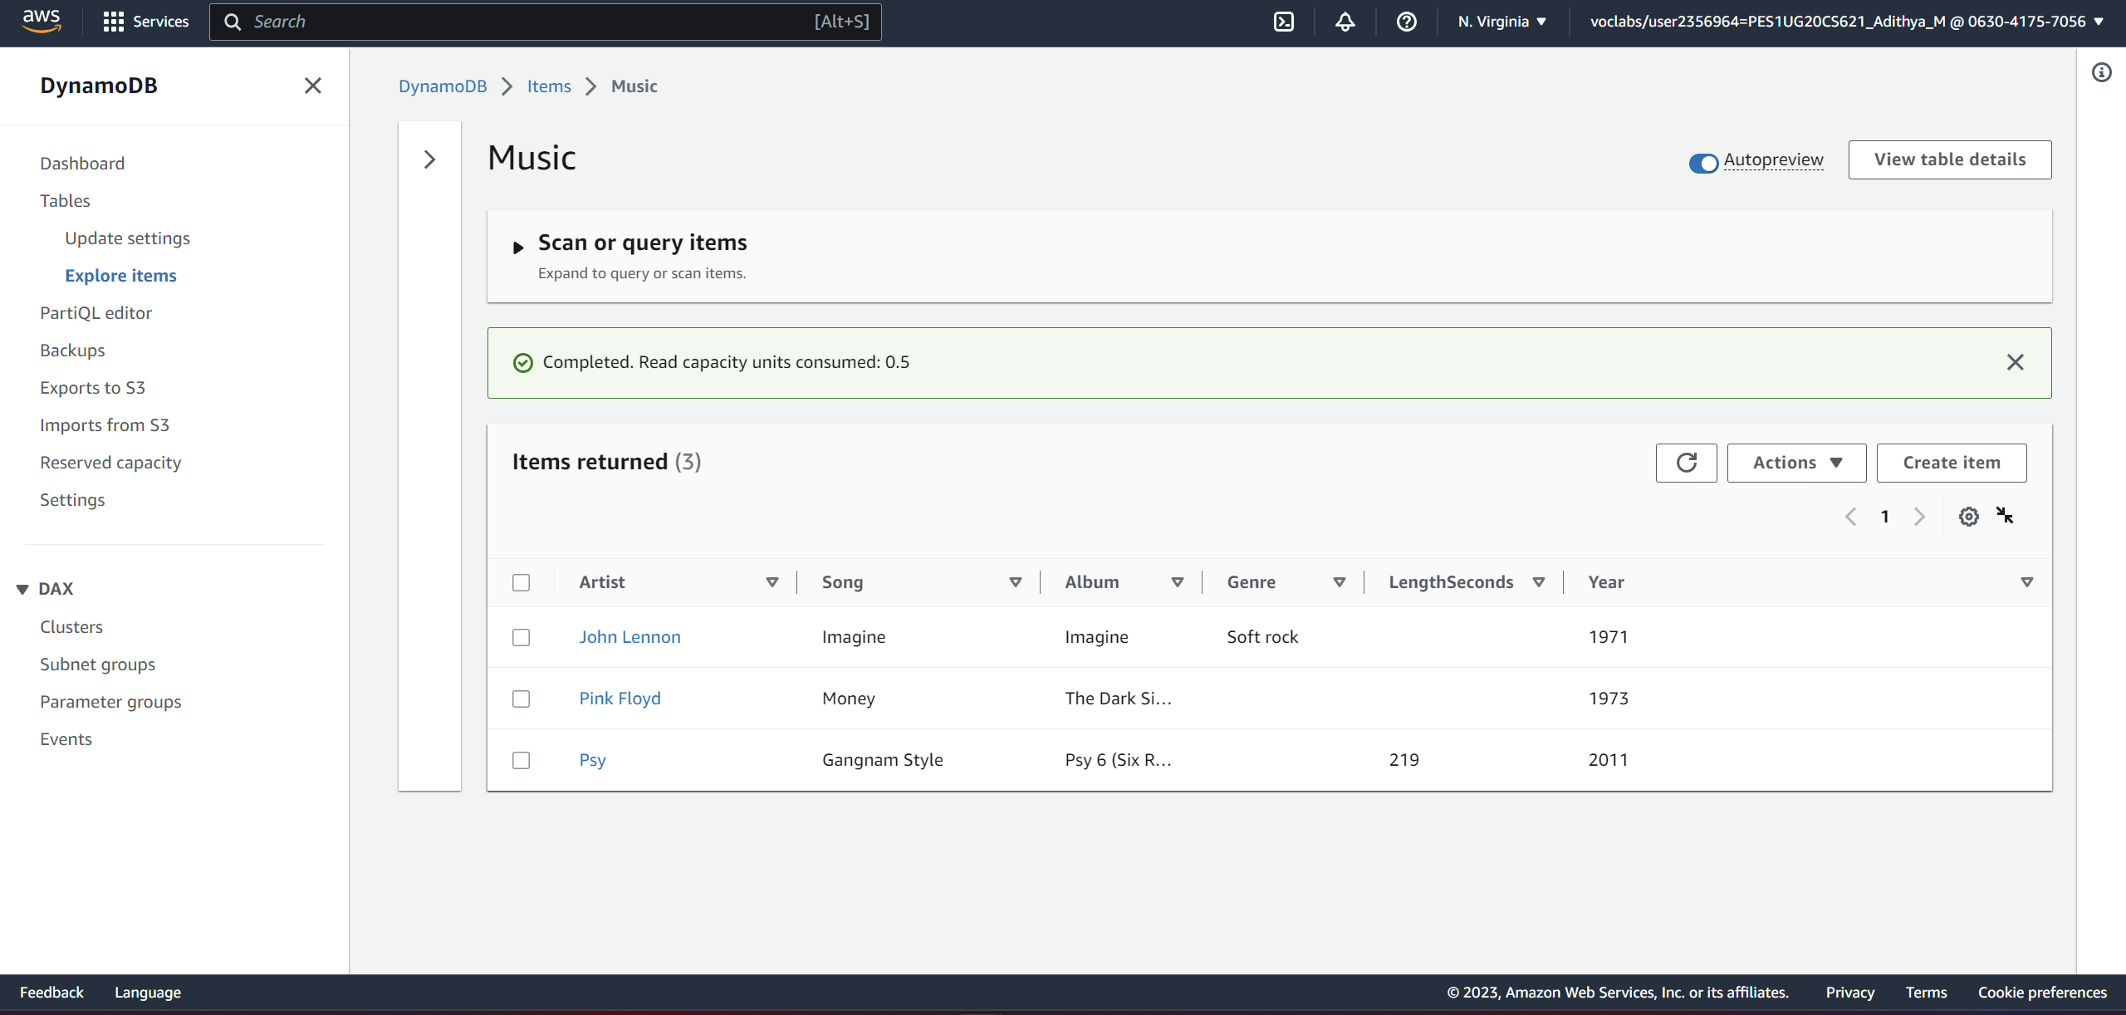

**● Screenshot 3a: Show the entries post update (Make sure the Items returned table is expanded such that all fields are shown and the name of the Table is also visible to the left) (2 marks)**

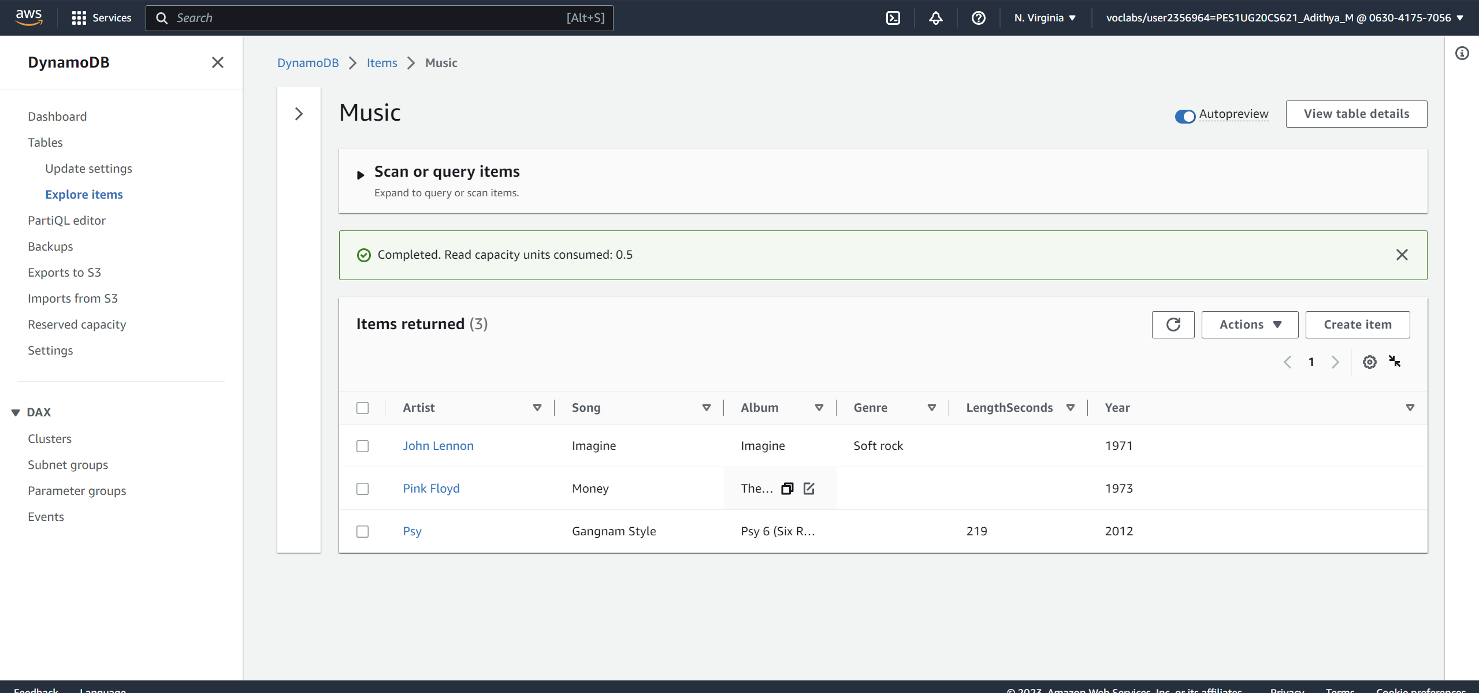

**● Screenshot 4a: Result of the query Artist (Partition key): Psy, Song (Sort key): Equal to Gangnam Style (Make sure both the query parameters filled are visible along with the result of the query) (2 marks)**

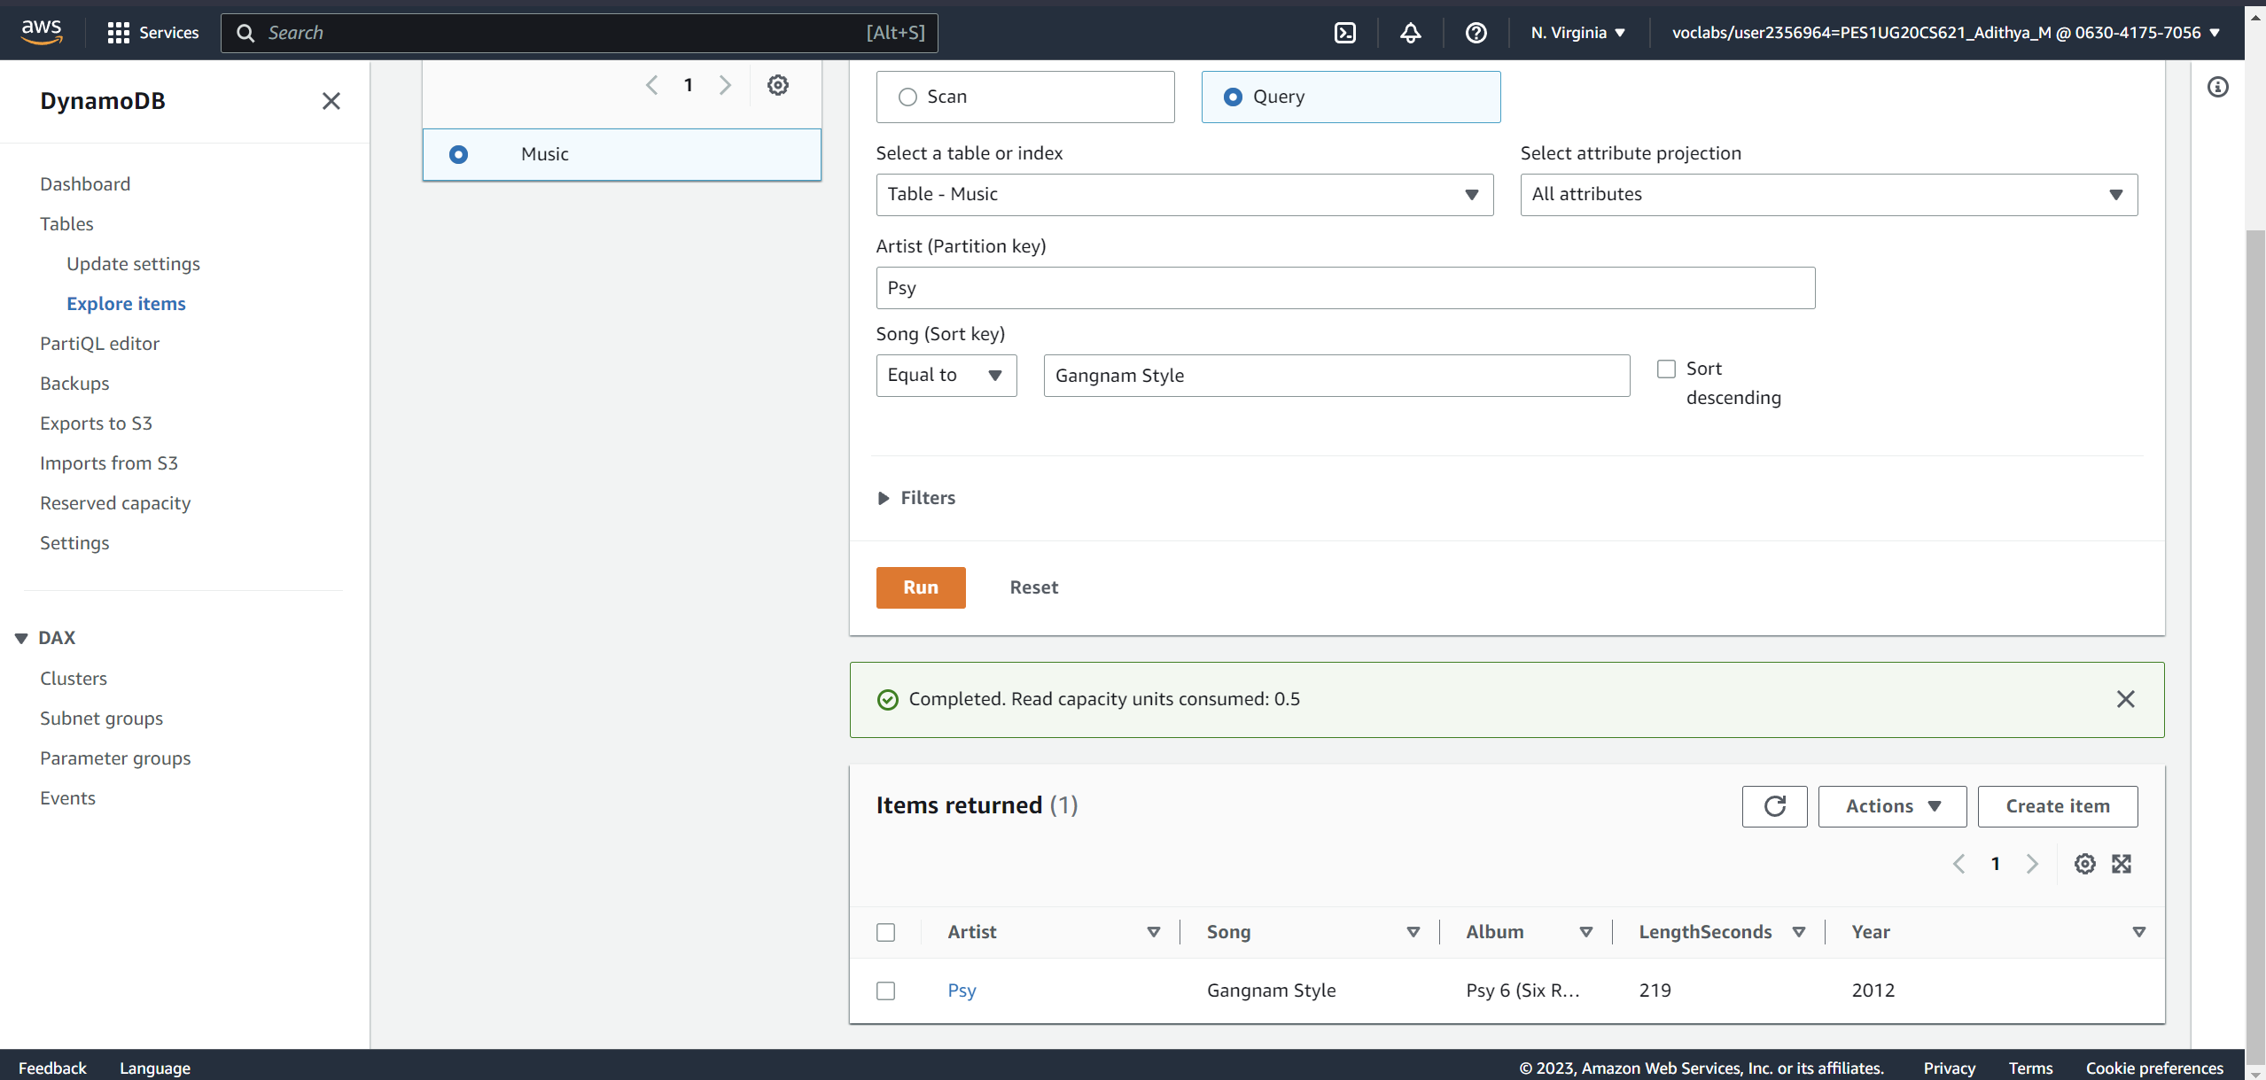

**● Screenshot 4b: Result of Scan filter (Make sure the ‘Scan’ radio button selection, Attribute name and the result are present in the screenshot) (2 marks)**

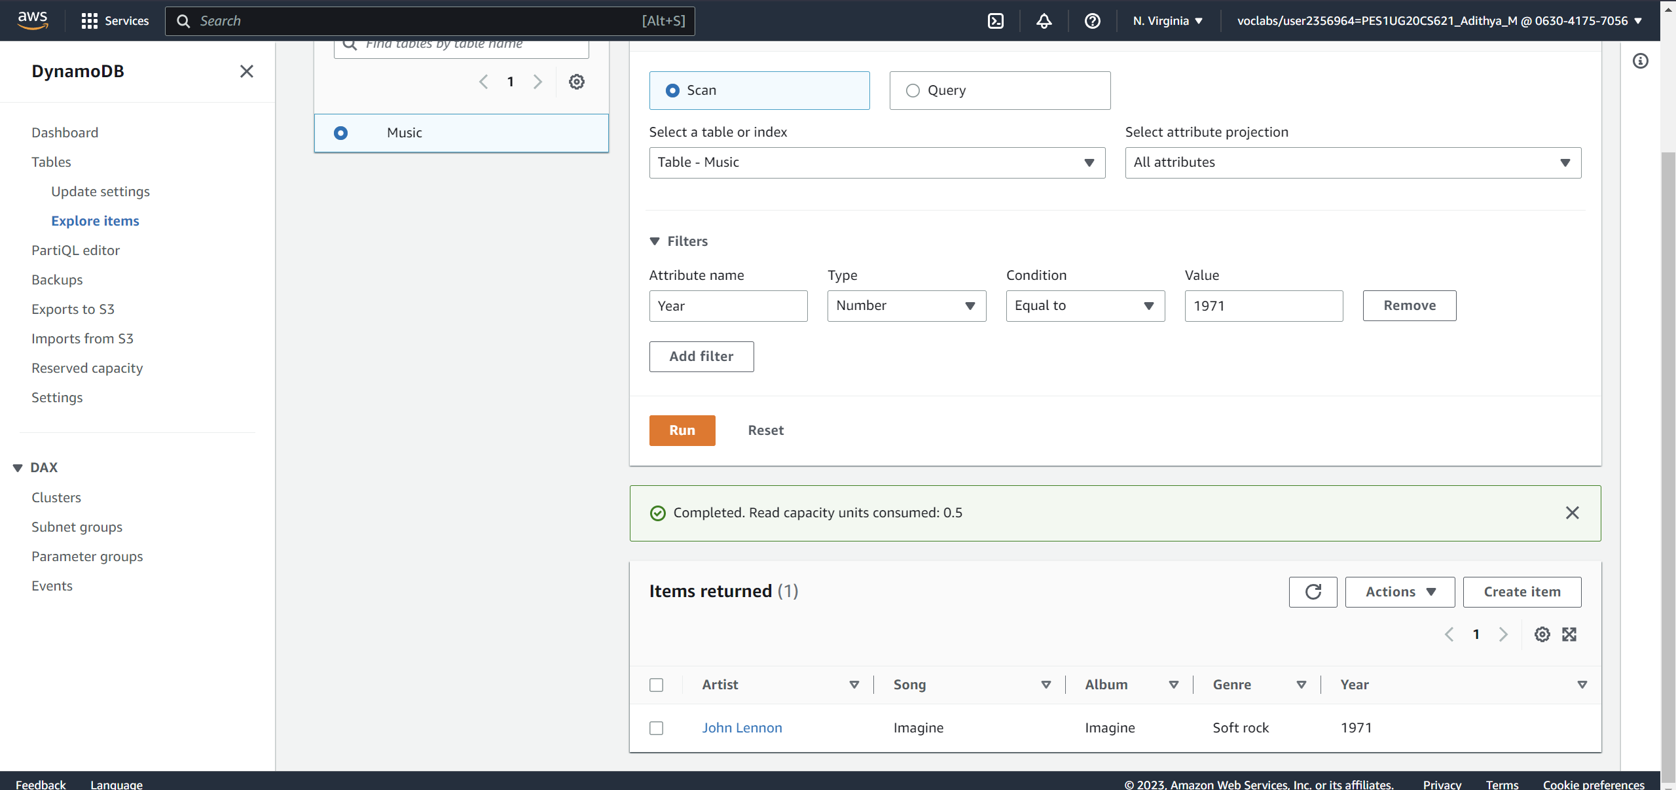

**● Screenshot 5a: Data after deletion of an item from the table (1 mark)**

